

## Smt. KASHIBAI NAVALE COLLEGE of ENGINEERING, PUNE-41

Sr.No. 44/1, Vadgaon (Bk), Off Sinhgad Road, Pune – 411 041.

Department of E&TC Engineering

***Certificate***

This is to certify that, following students,

1. AGUNDE SUYASH TANAJI Roll No: 501
2. DANDEKAR NAKUL HARBAN Roll No: 510
3. DAVE ANTARA PRAGNESH Roll No: 511
4. DISALE YOGITA BIBHISHAN Roll No: 514
5. GURME SWAPNIL SHRIDHAR Roll No: 517

has completed all the Term Work in the subject **Project Based Learning (PBL)** satisfactorily in the department of E&TC Engineering as prescribed by Savitribai Phule Pune University, in the academic year 2021-2022 SEM II.

Prof. Dr. P. G. Chilveri Dr.S.K.Jagtap

**Faculty-In-Charge Co-ordinator HoD E&TC**

**Date: / /**

**PID CONTROLLER BY USING MATLAB**

*A Report submitted in partial fulfillment of the requirements to complete Term Work of Project Base Learning (PBL) in the department of*

**ENTC ENGINEERING**

*As prescribed by*

**SAVITRIBAI PHULE PUNE UNIVERSITY**

*By*

**AGUNDE SUYASH TANAJI PRN NO: 72148594E**

**DANDEKAR NAKUL HARBAN PRN NO: 72148719L**

**DAVE ANTARA PRAGNESH PRN NO: 72148727M**

**DISALE YOGITA BIBHISHAN PRN NO: 72148756E**

**GURME SWAPNIL SHRIDHAR PRN NO: 72149295K**

*Under the Guidance of*

**PROF. SMITA INGAWALE MAM**



**E&TC ENGINEERING DEPARTMENT**

**SMT. KASHIBAI NAVALE COLLEGE OF ENGINEERING**

*44/1, Vadgaon (Bk), Off Sinhgad Road,*

*Pune – 411041.*

Abstract:

The acronym PID stands for Proportional-Integral-Differential control. Each of these, the P, the I and the D are terms in a control algorithm, and each has a special purpose. The purpose of this is to study and simulate PID controller using MATLAB. The PID controller algorithm involves three separate constant parameters and therefore sometimes it is called three-term controller. Each of these, the P, the I and the D are terms in a control algorithm, and each has a special purpose A PID controller continuously calculates an error value e(t) as difference between a desired set points and a measure process variable and applies a correction based on proportional, integral, derivative terms which gives controller its name, Where P depends on present error, I depends on accumulation on past errors, D is the prediction of future errors, based on current rate of change. The ability of proportional integral derivative (PID) controllers to compensate many practical industrial processes has led to their wide acceptance in industrial applications. The purpose of this study was to design PID controller using MATLAB software. The design of the PID controller with matlab simulation can be implemented precisely. As per studies it has been found that each control area requires PID type for process control systems. Over 85% of all dynamic (low level) controllers are of PID variety. The purpose of this report is to provide a brief overview of the PID controller. The simplicity, ease of implementation and robustness has attracted the use of Proportional, Integral and Derivative (PID) controllers in the chemical process industries.

Table of content:

|  |
| --- |
| 1. Abstract |
| 1. Table of contents |
| 1. Introduction |
| 1. Literature Survey |
| 1. Design of the proportional (P), Proportional plus Integral (PI) and |
| Proportional plus integral plus derivative (PID) Controllers |
| Controller. |
| 1. Code |
| 1. Simulation |
| 1. Result |
| 1. Conclusion |
| 1. References |

1.Introduction:

The PID controller is the most common form of comments. It was a fundamental sanction for the first rulers and became the standard instrument when process observation arose in the 1940's. In today's process control, over 95% of PID control loops, most of the loops are actually a PI control. PID controllers are found today in all areas where the control is used. Controls come in different shapes. There are stand-alone systems in boxes for one or a few rings, which are manufactured by hundreds of thousands per year. PID control is an important component of a distributed control system. Control units are also included in many special purpose control systems. PID control is often combined with logical, sequential functions, parameters, and simple function blocks for building complex automation systems used to produce, transmit, and manufacture energy. Many advanced control strategies, such as typical predictive control, are organized hierarchically. PID control is used at the lowest level; The multivariate console gives tuning points for lower-level control Thus it can be said that the PID controller is 'bread and butter' of control engineering. It is an important component of every control engineer’s toolbox. PID controllers have survived many changes in technology, from mechanics and compressed air to microprocessors via electronic tubes, transistors and integrated circuits. The microprocessor has had a major impact on the PID controller. Practically all PID controllers made today rely on microprocessors. This has provided opportunities to provide additional features such as automatic tuning, gain scheduling, and continuous adjustment.

Literature Survey:

The simplicity, ease of implementation has attracted the use of PID controller. This paper presents the technique for obtaining the FOPTD model ( First Order System With Time Delay ) using Sundaresan and Krishnaswamy method and performance comparison of PID controller based on open loop, closed loop tuning techniques and PID controller tuned with Internal Model Control (IMC ) technique.

Cost benefit ration obtained through PID controller is difficult to achieve by other controllers. It is found that 97% of the controllers found in industry use PID algorithm. The mathematical form of PID algorithm is :

GPID(s) = Gc(s)=Kp( 1+ 1/TiS+TdS )

where , Gc(s) is the controller transfer function , Kp - proportional gain , Ti - internal time and Td- Derivative time. This paper focuses on Identifying the First Order Plus Time Delay (FOPDT) process models from step response data , Design of PID controller from the identified model using open loop, closed loop tuning techniques and IMC tuned PID , Performance evaluation of the designed PID controller through simulation for setpoint tracking and disturbance rejection. **[ 1]**

This is the study of tuning of PID controller by using Practical Swarm Optimization. This paper presents a detailed overview of the basic concepts of PSO and its variants. The proposed method utilizes the Particle Swarm Optimization (PSO) algorithm approach to generate the optimal tuning parameters. The paper deals with optimal tuning of proportional integral derivative (PID) controller for controlling the output obtained and hence to minimize the integral of absolute errors.

Study of Optimization Technique (PSO):

In 1995, Kennedy and Eberhart first introduced the particle swarm optimization (PSO) method. It is one of the optimization techniques and a kind of evolutionary computation technique. The features of the method are- The method is developed from research on swarm such as fish schooling and bird flocking, It can be easily implemented, and has stable convergence characteristic with good computational efficiency.

In this paper it is verified that by varying different parameters of the PID controller the response of the system is changing. Hence by changing kp ,ki, and kd the response of the system is improved. Also the peak overshoot, the rise time and the settling time of the system is reduced. Hence this method is a design method for determining the PID controller parameters . It can obtain higher quality solution with better computational efficiency. **[ 2]**

This paper is a study of design and implementation of stable PID Controller for Interacting Level Control System. In this study a Stability Region Analysis method for designing PID controller for time delay system is validated with real time experimentation with Interacting process. The higher order system is reduced into first order plus time delay (FOPDT) model. Author have presented one simulation example and experimental validation on Interacting Level Control System.

In this paper author have presented easy and reliable tuning method of PID controller for reduced FOPDT model. The stability regions of time-delay systems with PID controllers shows the effectiveness of the stable PID tuning method. The validity of the method is determine by dual-locus diagram.

An experimental validation of the method is done by applying this method to simple Interacting level control loop. The controller designed with the given method provides good set point tracking and also offers better disturbance rejection. The stability region analysis method is applicable only for the FOPDT model of process and it is simplest method used for tuning of the PID controller. **[ 3]**

This paper is a study of a Proportional–Integral–Derivative Controller for COVID-19 Outbreak Containment. A good understanding of the system reaction to any change of the input control variable can be reasonably achieved using a proportional–integral–derivative controller (PID), which is a widely used technique in various physics and technological applications. In this paper, this control theory to is proposed to be applied epidemiology, to understand the reaction of COVID-19 propagation to social restrictions and to reduce epidemic damages through the correct tuning of the containment policy. In this paper, the use of the proportional–integral–derivative (PID) control theory for the COVID-19 epidemic control is proposed. This well-established technique can be useful both for understanding the behavior of the infected population during an intermittent lockdown and for defining a strategy for a lockdown policy to establish optimal control. In particular, it is demonstrated that the COVID-19 outbreak, with the attempt at containment through social restrictions by governments, can be modelled and understood in terms of the PID controller mechanism, which is used in various applications of complex systems.

Using a simple time-dependent modification of the SIR modelling of the COVID-19 outbreak evolution, a test-bench model called SIR-PID is built to test the possibility of using a PID controller to achieve the desired containment threshold smoothly, aiming at avoiding serious damages in terms of economical crisis and especially in terms of human life costs. The implementation assumes the basic reproduction number, R0, as input parameter and the number of infected (or active cases) as output. Even if R0 is not directly accessible as an input parameter, it can be reasonably substituted by people’s mobility, which can be easily estimated and classified in a gradation scale ranging from a drastic lockdown to the free evolution of the pandemic. In addition, a numerical recipe is provided for simulating the epidemic that can be extended to more complex epidemiological models.

In the study, it is shown that, in using a loop-tuning procedure, this goal was achieve- able in a satisfactory way. This result allows us to exploit this procedure on real data, even if the real COVID-19 outbreak system is more complex due to other potential effects contributing to the time variation of R0. For the basic model considered, it is shown that the best way of achieving an optimal control is to react promptly at the beginning of the pandemic by lowering the mobility by a factor of two and then to increase the social re- strictions slowly to reach the desired set-point that is deemed affordable for the healthcare system. This procedure is desirable when the pandemic is already out of control over a wide geographical area because the first attempt should be the complete confinement of the outbreak by drastically limiting the patient zero areas and nearest contacts, when possible.

The advantage of using a well-known PID control theory instead of relying on tra- ditional control methods, based on numerical simulations and rules suggested by the experience, is mainly its flexibility. **[4]**

Tuning a PID controller:

Tuning a PID controller appears easy, requiring you to find just three values: proportional, integral, and derivative gains. In fact, safely and systematically finding the set of gains that ensures the best performance of your control system is a complex task. Using a four-bar linkage system as an example, this article describes a method that simplifies and improves the design and implementation of PID controllers. This method is based on two R2009b product features: the PID Controller blocks in Simulink® and the PID tuning algorithm in Simulink Control Design.

The Four-Bar Linkage System:

Four-bar linkage is used in a wide range of applications, including car suspensions, robot actuators and aircraft landing gears.

The control system consists of two elements: feedforward control and feedback PID control. Feedforward control inverts plant dynamics, it handles the major motion of the mechanism by taking into Four-bar linkage mechanism with stationary lower link colored in blue. Feedback PID control keeps positioning errors small in the face of modeling uncertainties and external disturbances.

Then the Closed-Loop System is configured and The PID controller is tuned. After tuning the PID controller, it is prepared for implementation on a 16-bit microprocessor we scale it for the fixed-point arithmetic supported by the chip.

Generation of Product code:

After that we generate the production code. With the PID controller prepared for implementation, the final step is to use Real-Time Workshop Embedded Coder to generate C code. To test this code, we replace the PID Controller block with the generated C code and run the code in closed-loop simulation. We can now run the simulation us- ing the C code that will run on the actual processor. **[ 5]**

2.PID Controller Survey:

Proportional-integral-Derivative Controller (PID) is a control loop (control) feedback mechanism widely used in industrial control systems. PID calculates the amount of error as the difference between the measured process variable and the required output. The console tries to reduce the error by modifying the process by using a handler variable. The PID controller algorithm includes three separate static parameters, hence sometimes called a three-term control: relative, integral, and derived values referred to as P, I, and D. Simply, these values can be interpreted in terms of time: P depends on the current error, and I am accumulating Previous errors, and D is a prediction of future errors, based on the current rate of change. The weighted sum of these three measures is used to adjust the process via a control such as the position of the control valve, damper, or power supplied to the heating element. In the absence of knowledge of the basic process, the PID controller has historically been considered the most useful console. By adjusting the three parameters in the PID controller algorithm, the controller can provide a control procedure designed for specific process requirements. The console response can be described in terms of the console's response to an error, the degree to which the console exceeds the setpoint, and the degree of system fluctuation. Note that the use of the PID control algorithm does not guarantee optimum system control or system stability. Some applications may require only one or two procedures to provide adequate control of the system. This is accomplished by setting the other parameters to zero. The PID controller will be called the PI, PD, P or I controller if the respective control procedures are not present. PI controllers are fairly common because the derived procedure is sensitive to measurement noise, while the absence of an integrated term may prevent the system from reaching the target value due to the control action.

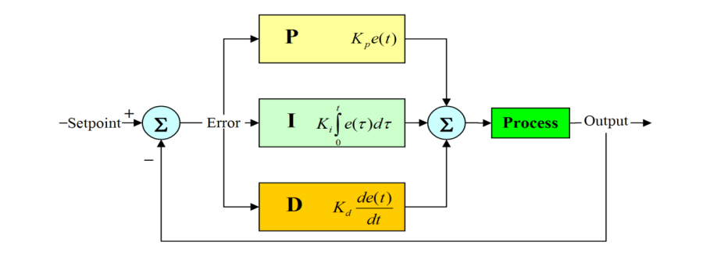History of PID controller:

Continuous control, before PID controllers are fully understood and implemented, has one of its origins in the centrifugal ruler, which uses rotating weights to control the process. This was invented by Christiaan Huygens in the seventeenth century to organize the gap between the mill stones in the windmills depending on the rotational speed, thus compensating for the variable speed of the grain feed. With the invention of the low-pressure stationary steam engine, automatic speed control was required, and the self-designed 'conical pendulum' ruler of James Watt, a group of rotating steel balls connected to a vertical spindle with joint arms, became the industry standard. This was based on the concept of controlling the millet gap However, the speed control of the rotary ruler was variable under variable load conditions, as the deficiency in what is now known as relative control alone was evident. The error will increase between the required speed and the actual speed as the load increases. In the nineteenth century, the theoretical basis for the operation of rulers was first described by James Clerk Maxwell in 1868 in his famous paper on rulers. He explored the mathematical basis for control stability and progressed well toward the solution but appealed to mathematicians to study the problem. The problem was further examined by Edward Roth in 1874, Charles Storm, and in 1895, Adolf Horowitz, all of whom contributed to setting standards for stability In later applications, speed arbitrators were further improved, particularly by the American scientist Willard Gibbs, who in 1872 undertook a theoretical analysis of the conical Watt Pend. Around this time, the invention of the white torpedo was a control problem that required precise control over the depth of operation. The use of a depth pressure sensor alone proved insufficient, and the pendulum, which measures the degree of the front and back phase of the torpedo, was combined with the depth measurement to become the control of the pendulum and hydro state Pressure control only provided relative control, if the control gain is too high, it will become unstable and go to excesses with great instability in depth retention. The pendulum added what is now known as derivative control, which reduced oscillations by revealing the torque diving / climbing angle and thus the rate of depth change.

Theory of PID controller:

The PID control chart is named after the three correction terms, the sum of which is the processor variable (MV). Relative, integral, and derived terms are combined to calculate PID controller output. By specifying 𝑢 (𝑡) as the output of the controller, controller manufacturers arrange proportional, integrated, and derived modes in three different control algorithms or control structures. It is called interactive, non-interactive and parallel algorithms. Some console manufacturers allow you to choose between different console algorithms as a configuration option in the console software. PID algorithms

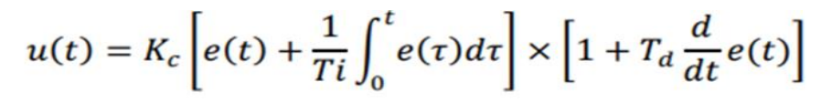

Interactive Algorithm

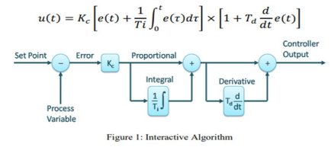

Noninteractive Algorithm

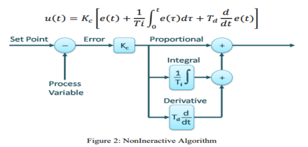

Parallel Algorithm

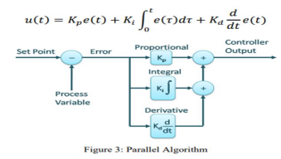

Where,

𝐾𝑝 = 𝐾𝑐: 𝑃𝑟𝑜𝑝𝑜𝑡𝑖𝑜𝑛𝑎𝑙 𝐺𝑎𝑖𝑛

𝐾𝑖 = Kc/Ti: Integral Gain

𝐾𝑑 = 𝐾𝑐𝑇𝑑:𝐷𝑒𝑟𝑖𝑣𝑎𝑡𝑖𝑣𝑒 𝐺𝑎𝑖𝑛

𝑒(𝑡) = 𝑟(𝑡) − 𝑦(𝑡)

• proportional term

The relative term results in an output value that is proportional to the current

error value. The relative response can be adjusted by multiplying the error in the

Kp constant, called the relative gain constant.

The relative term is given:

𝑷𝒐𝒖𝒕 = 𝑲𝒑𝑒(𝑡)

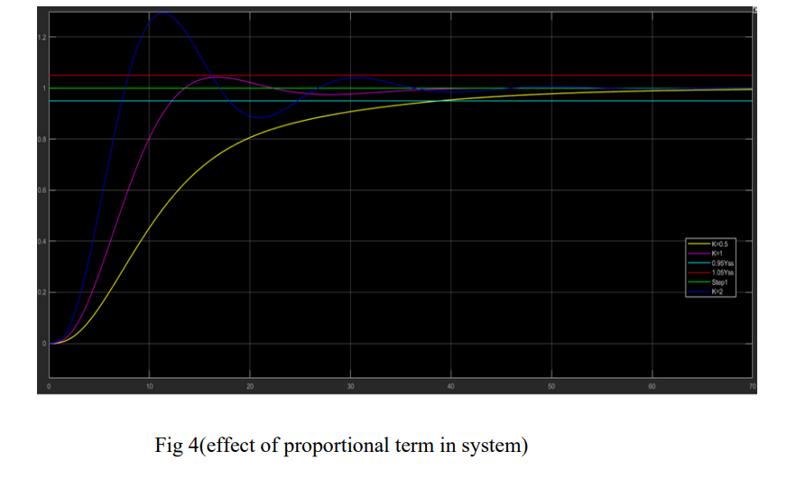Higher relative gain results in a significant change in output of a given change in error. as shown in fig. (4) If the relative gain is too high, the system may become unstable. In contrast, small gain results in a small output response to a large input error, and a less responsive or less sensitive controller. If the relative gain is very low, the control procedure may be very small in response to system disturbances. Control theory and industrial practice indicate that the relative term should contribute to the greater part of the output change.

• Proportional Mode Advantages

1) Minimize dead time from stiction and backlash

2) Minimize rise time

3) Minimize peak error

4) Minimize integrated error

• Proportional Mode Disadvantages

1) Abrupt changes in output upset operators

2) Abrupt changes in output upset other loops

3) Amplification of noise

• Integral term

The contribution of the integrated term is proportional to both the magnitude of

the error and the duration of the error.as shown in fig. (5)

Integration in the PID controller is the sum of instantaneous error over time and

gives the accumulated offset that should have been previously corrected. The

accumulated error is then multiplied by the full gain 𝑲𝒊 and added to the console output.



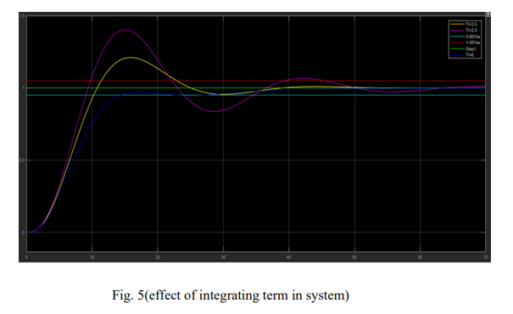

The integrated term speeds up the process’s movement towards the point of selection and removes the remaining static error that occurs with a pure proportional controller. However, since the term integral responds to errors accumulated from the past, it may cause the current value to exceed the specified point value.

• Integral Mode Advantages

1) Eliminate offset

2) Minimize integrated error

3) Smooth movement of output

• Integral Mode disadvantages

1) Limit cycles

2) Overshoot

3) Runaway of open loop unstable reactors

• Derivative term

The process error derivative is calculated by setting the slope of the error over

time and multiplying this rate of change in the derivative of the derivative 𝐾d.

The magnitude of the derivative's contribution to the total control procedure is

called the derivative gain, 𝐾d. The term derivative is given by

**D**𝒐𝒖𝒕 = 𝑲𝒑 𝒅/𝒅𝒕 **𝑒(𝑡)**

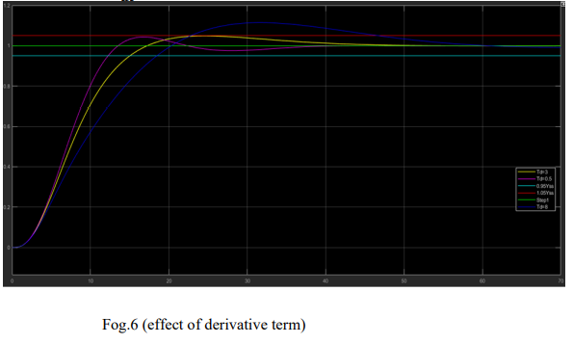

Derivative work predicts system behavior and thus improves time stability and system stability. As shown in figure (6) The ideal derivative is not causative, so PID controller applications include a low additional pass filter for the derivative term, to reduce high frequency gain and noise. In practice, derivative procedures are rarely used - despite only one estimate in only 20% of the deployed controllers - because of their variable impact on system stability in real-world applications.

• Derivative Mode Advantages

Minimize dead time from stiction and backlash

Minimize rise time

Minimize peak error

Minimize integrated error

• Derivative Mode disadvantages

Minimize dead time from stiction and backlash

Minimize rise time

Minimize peak error

Minimize integrated error

Applications of PID controller:

Relative-Integrated-Derivative Controls (PID) are used in most automatic process control applications in the industry today to regulate flow, temperature, pressure, level, and many other industrial process variables. It dates back to 1939, when Taylor and Foxboro instrument companies introduced the first two PIDs. All controllers nowadays rely on these original, integral, and derivative modes. PID controllers are the backbone of modern process control systems, automating the mapping tasks that had to be done manually. While the proportional control mode is the main driving force in the console, each mode performs a unique function. Proportional and integrated control modes are essential for most control rings, while the derivative mode is excellent for movement control. Temperature control is a typical application that uses three control modes Manual control

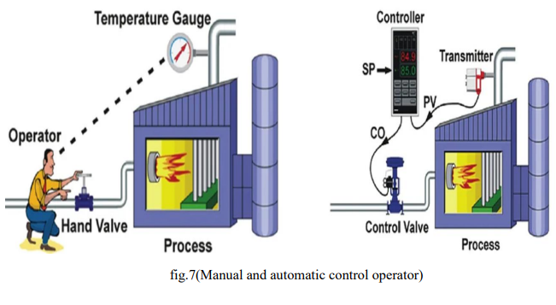

Figure (7). Manual control operator Without PID control, manual control of water temperature is laborious. For example, to maintain a constant temperature of water being discharged from an industrial gas heater, the operator should monitor the temperature gauge and adjust the fuel gas valve accordingly Figure (7). If the water temperature becomes too high, the operator must close the gas valve enough to return the temperature to the desired value. If the water becomes too cold, he must open the gas valve.

The operator's control task is called controlling the feedback, because the operator changes the launch rate based on the feedback from the process via the temperature scale. The actuator, valve, handle and temperature gauge form a control ring. Any change made by the actuator to the gas valve affects the temperature, which is returned to the actuator, thus closing the loop.

Automatic control

To automate temperature control with a PID controller, the following is required:

• Install an electronic temperature measuring device

• Automate the valve by adding a driver (and possibly a GPS device) so it can be

operated electronically

• Install a controller and connect it to the temperature meter and the automatically

removed control valve

1. Design of the proportional (P), Proportional plus Integral (PI) and Proportional plus integral plus derivative (PID) Controllers:

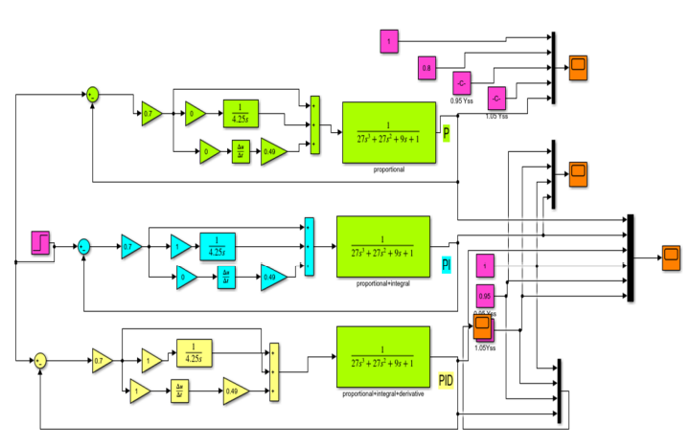

6.Code:

Design PID Controller in MATLAB:

% PID Control Example

close all; clear all;

% Define the System

s = tf('s');

sys = 1/(s^2 + 10*s + 20);

% Defining gains for PID

Kp = 250;

Ki = 200;

Kd = 0;

% Defining Controller

controller = Kp + Ki/s + Kd*s;

% creating closed loop transfer function

cl_sys = feedback(controller * sys, 1);

% taking step response

step(1,1);hold on;

step(sys); hold on;

step(cl_sys);

legend('reference','open loop','closed loop (PID');

Simulation:

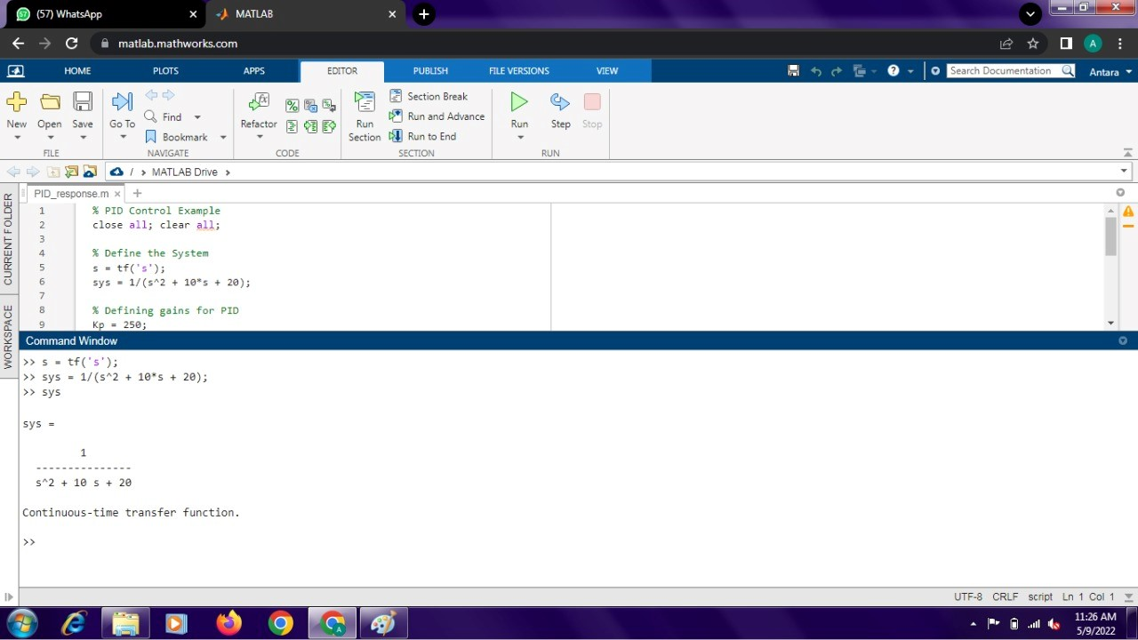

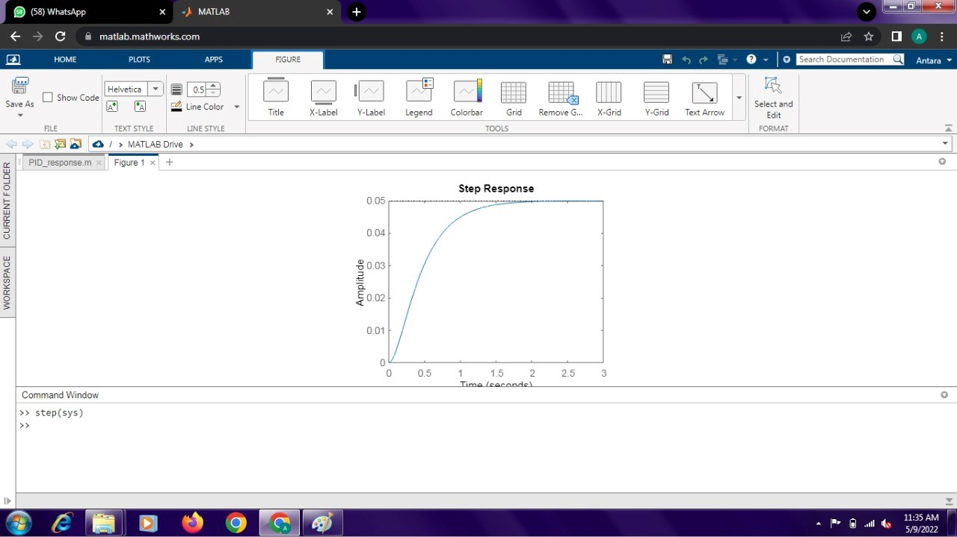

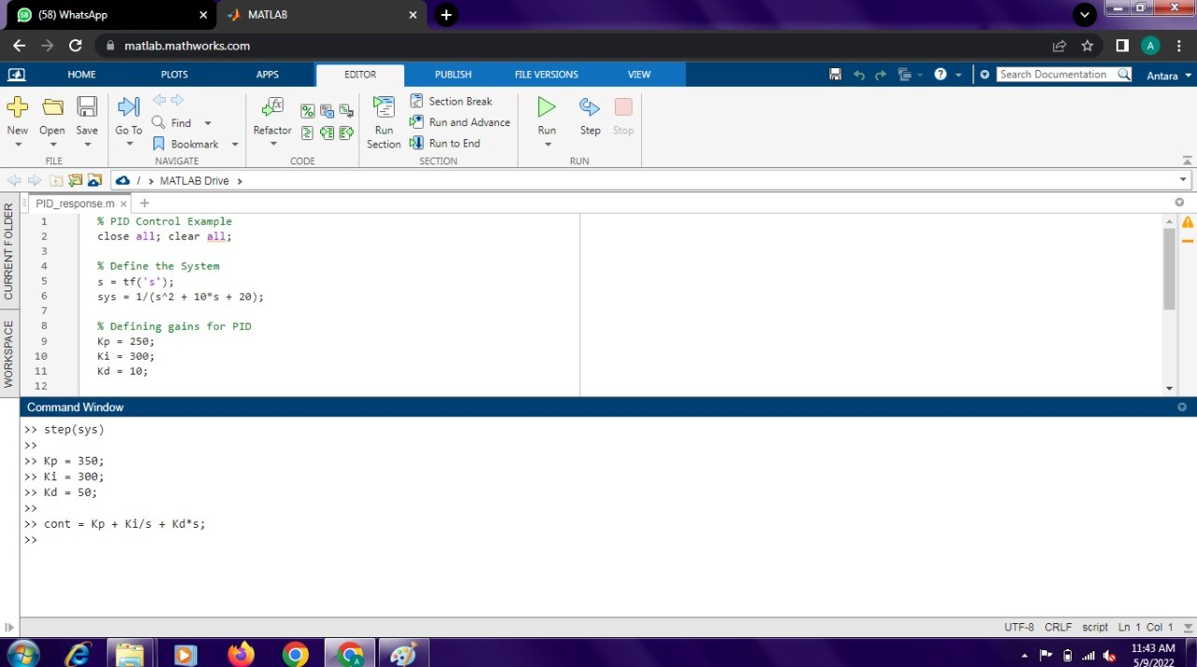

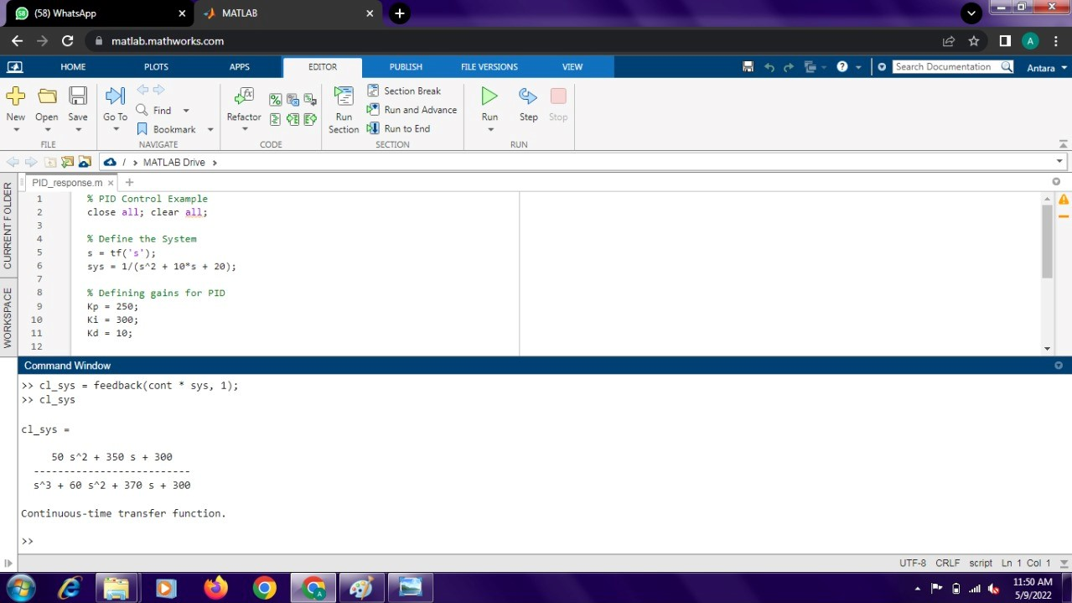

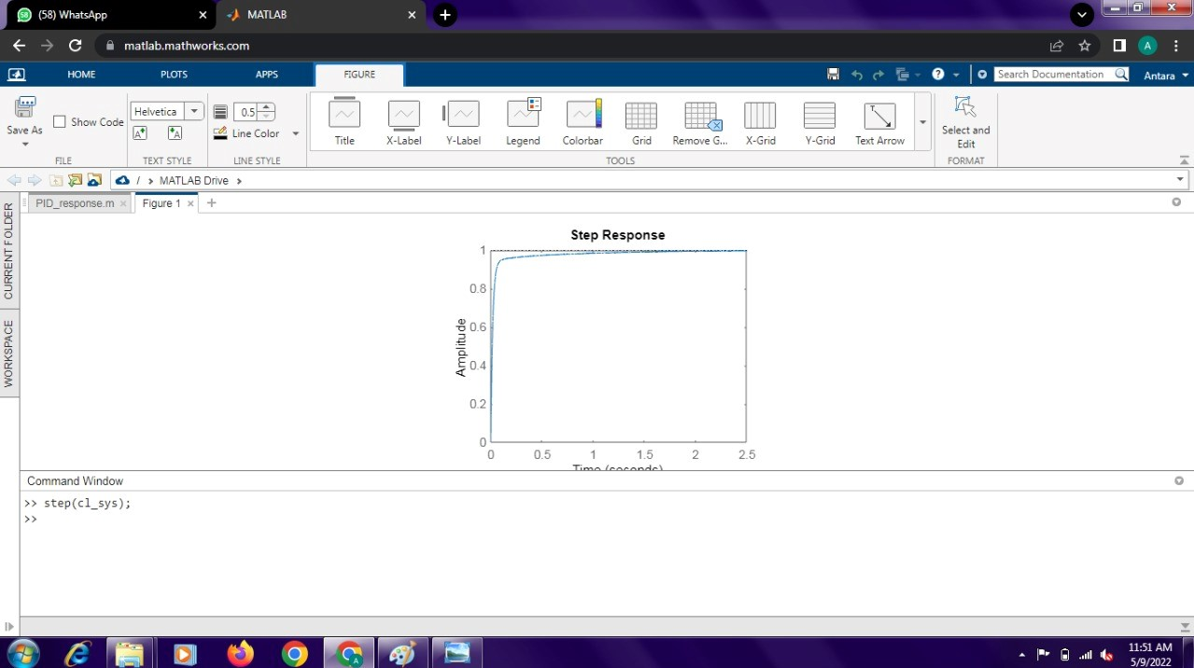

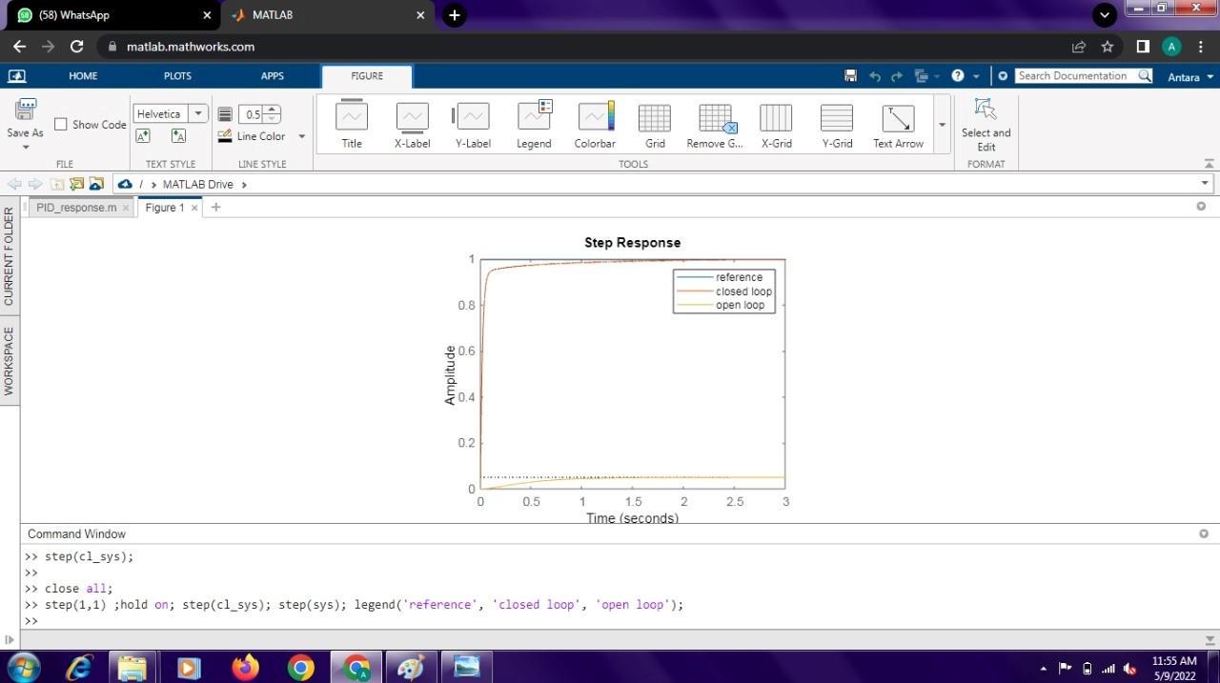

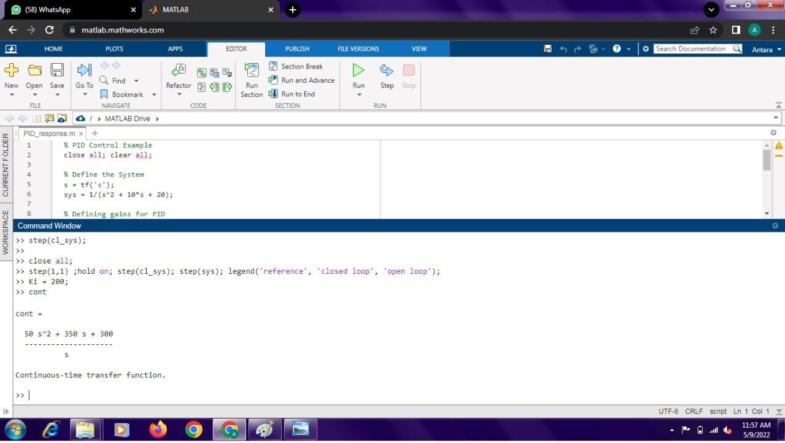

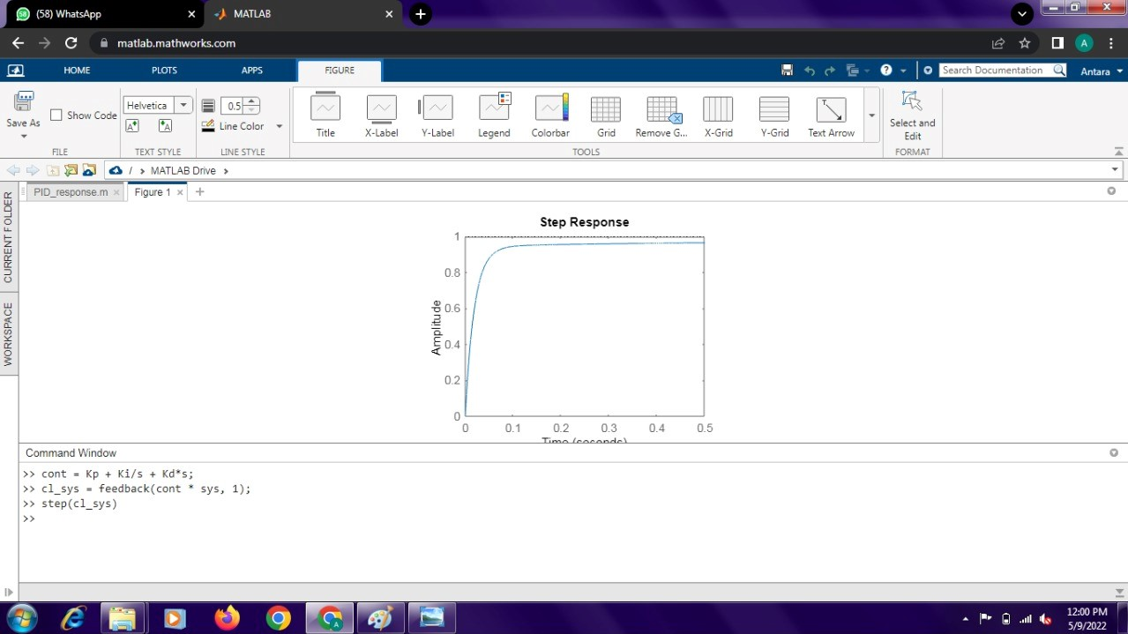

Result:

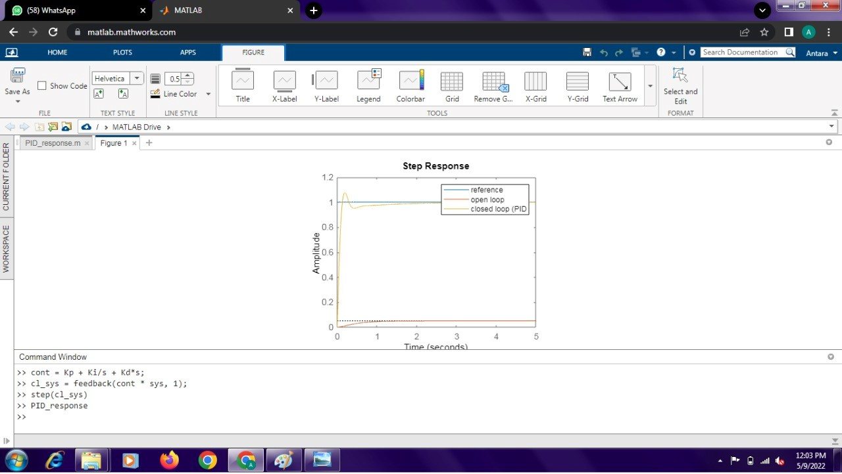

Conclusion:

Modern process control systems cannot exist without PID controllers, all control functions must be performed manually. Each proportional, integrated and derived control mode fulfills a unique function, and the setting rules have been developed to ensure effective process control for all types of loops and applications

References:

1. M. Lee, M. Shamsuzzoha, and T.N. Luan Vu, ―IMC-PID Approach: An Effective way to get an Analytical Design of Robust PID Controller,‖ International Conference on Control, Automation and Systems, Seoul, Korea, pp. 2861–2866, 2008.
2. Zwe-Lee Gaing, “ A particle swarm optimization approach for optimum design of PID controller in AVR system”, IEEE transactions on energy conversion,November 6,(2002).
3. Jihong Li and Pingkang Li, “Stability Region Analysis of PID Controllers for Time-delay Systems”, Proceeding of the 6thWorld Congress on Intelligent Control and automation, June 21-23, 2219-2223, © 2006 IEEE.
4. Ang, K.H.; Chong, G.; Li, Y. PID control system analysis, design, and technology. IEEE Trans. Control Syst. Technol. 2005, 13, 559–576. [CrossRef]
5. Meshram, P. M., and Rohit G. Kanojiya, "Tuning of PID cont roller using Ziegler-Nichols method for speed control of DC motor," Advances in Engineering, Science and Management (ICAESM), 2012 International Conference on, pp. 117-122. IEEE, 2012